MPH-IDE Advising Sheet
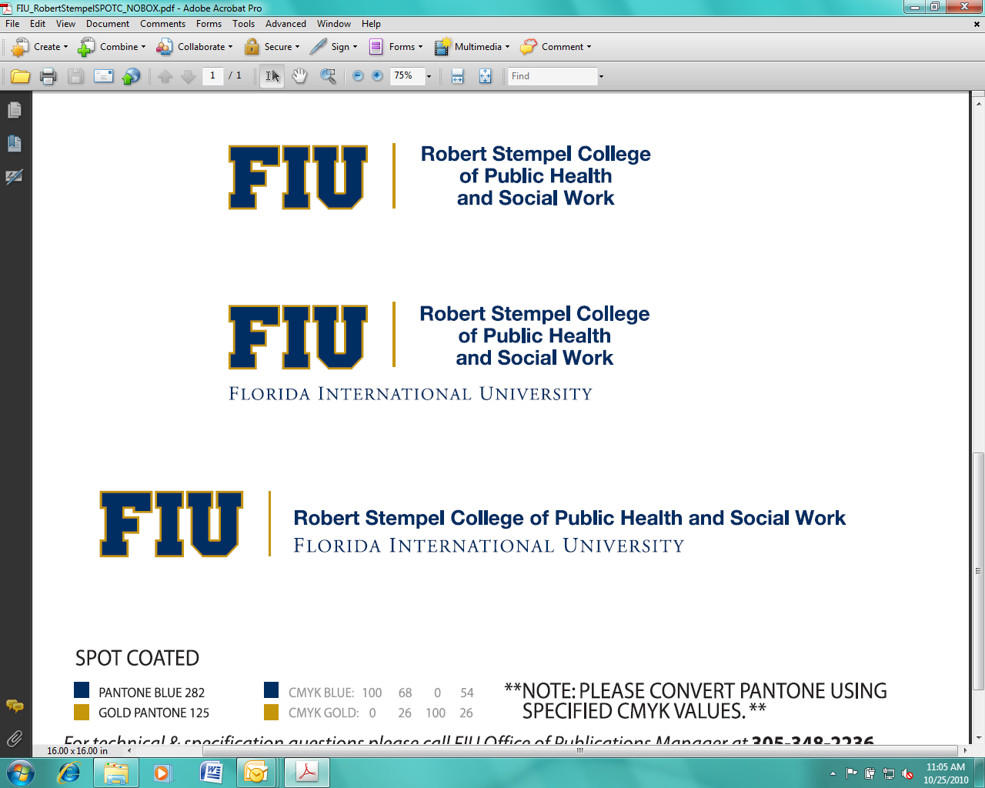
Master of Public Health with specialization in Infectious Disease Epidemiology
RSCPHSW: rscphsw.fiu.edu; Careers in Public Health: www.asph.org;
Course Registration: https:/my.fiu.edu

NAME: PID #: ADMITTED:

I. Public Health Core Courses: 15 credits of required coursework. Must earn a grade of B or better. A grade of B- in one Core Course will be allowed. Department requires that PH core courses PHC 6000 and PHC 6065 be taken before other requirements.

PREFIX | COURSE DESCRIPTION | HOURS | TERM | GRADE | PREREQUISITES
PHC 6000 | Epidemiology I: Introduction to Public Health Epidemiology | 3 | Fall Yr 1
PHC 6102 | Health Policy in a Global Context | 3 | Summer Yr 1
PHC 6052 | Biostatistics I | 3 | Fall Yr 1
PHC 6315 | Introduction to Environmental Health | 3 | Spr Yr 1
PHC 6410 | Health Behavior and Public Health | 3 | Fall Yr 1

II. Epidemiology Core Courses: 15 credits of required coursework.
PREFIX | COURSE DESCRIPTION | HOURS | TERM | GRADE | PREREQUISITES
PHC 6002 | Infectious Disease Epidemiology | 3 | Fall Yr 2 |  | PHC 6000 and PHC 6052
PHC 6013 | Epidemiology II:  Observational Design | 3 | Spr Yr 1 |  | PHC 6000 and PHC 6052
PHC 6003  OR | Chronic Disease Epidemiology (even years) | 3
PHC 6008  OR  PHC 6007 | Cardiovascular Disease Epidemiology(odd years)  Cancer Epidemiology | 3 | Spr Yr 2
PHC 6016  OR | Social Epidemiology (even years) | 3 | Spr Yr 2 |  | PHC 6000 and PHC 6052
PHC 6441 | Epidemiology of Health Disparity (every year) | 3 | Fall Yr 2
PHC  6091 OR  PHC 6080 | Biostatistics II  OR  SAS Computing for the Health Sciences | 3 | Spr Yr 1 |  | PHC 6052

III. Infectious and Tropical Disease Concentration Courses: 9 credits

PREFIX | COURSE DESCRIPTION | HOURS | TERM | GRADE | PREREQUISITES
PHC 6510 | Advanced Infectious Disease Epidemiology | 3 | Spr Yr 2 |  | PHC 6000 and  PHC 6002
PHC 6009 | AIDS Epidemiology and Control | 3 | Summer Yr 1 |  | PHC 6000 and  PHC 6052
PHC 6591  OR  PHC 6039 | Reproductive Health Epidemiology (odd years)  Healthcare and Infection Control Epidemiology (even years) | 3 | Spr Yr 2 |  | PHC 6000 and  PHC 6052

IV. Practicum and Culminating Experience Courses – 3 credits of required coursework.
To be eligible for practicum, students must have completed most of the MPH Core and EPI Required Courses. Please contact the Practicum Coordinator two semesters before you plan to take PHC 6945.

PREFIX | COURSE NAME | HOURS | TERM | GRADE | PREREQUISITES
PHC 6945 | Practicum in Public Health  (200 hours of practicum) | 2 | Spring Yr 2 |  | Permission of Practicum  Coordinator
Students with 3 or more years of practical experience in the PH field may apply for a waiver of PHC 6945 with the Practicum Coordinator. If approved, the student must complete 2 additional credits of PH coursework AND PHC 6930C.
PHC 6930C | Integrative Seminar in Public Health | 1 | Summer Yr 2 (or last term) |  | PHC 6945. Permission of  Practicum Coordinator

Graduation Requirements:
1. Satisfy all University requirements for Master of Public Health in Epidemiology.
2. Complete a minimum of 42 semester hours of graduate level coursework in approved program.
3. Earn a minimum overall GPA of 3.0 in all coursework completed.
4. Resolve incomplete grades prior to graduation. Resolve failing grades of required coursework prior to graduation.
5. Meet with Academic Advisor each Fall and Spring semester (Departmental graduation requirement).
6. Apply for graduation online at my.fiu.edu. (See Univ. Grad Catalog for most current deadlines).
7. Complete Robert Stempel School of Public Health Exit Survey prior to graduation.
8. All work applicable to the degree must be completed within six years of first enrollment in the master’s program.

If you are an international student or are receiving financial aid such that you are required to have a minimum number of credits each semester, please discuss this with your advisor several semesters prior to graduation to ensure that you are enrolled in enough credits your last semester.

