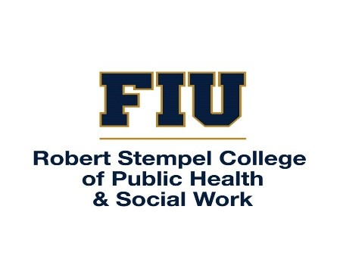
FIELD INSTRUCTORS’ TRAININGS
FIU’s School of Social Work is happy to provide twice-yearly Field Instructors’ Trainings (12 CEUs). The trainings are two days, one in-person and one on zoom. The Field Instructors’ trainings are free of charge to any MSWs with 2 years of practice experience post-MSW who plan to serve as a Field Instructor to FIU social work students. The Field Instructors’ Training also count toward the Florida Board of Clinical Social Work, Marriage & Family Therapy, and Mental Health Counseling’s Qualified Supervisor Training. Any individuals interested in receiving the Qualified Training are welcome to attend the full training for $175. CEUs are available to LCSWs, LMFTs, and LMHCs.

To register, please contact sowpracticum@fiu.edu.

2024-2025
Fall 2024
September 20 & 27, 2024
Spring 2025
January 24 & 31, 2025

2024-2025
Fall 2025
September 19 & 26, 2024
Spring 2026
January 23 & 30, 2026

