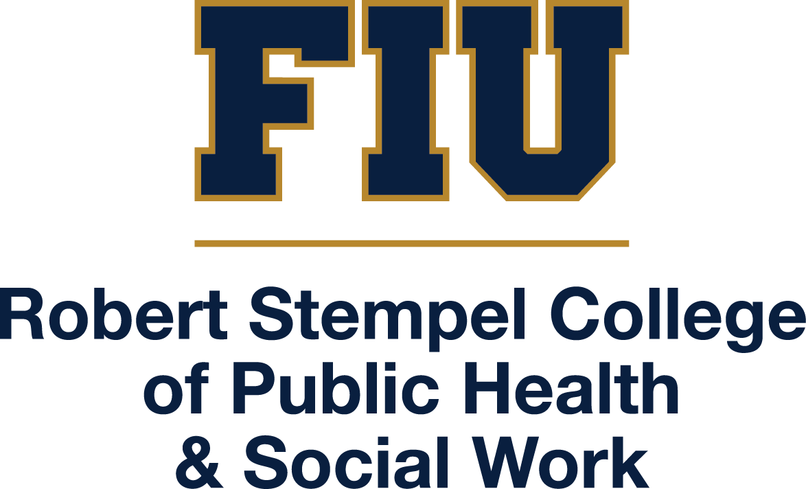

Master of Science in
Dietetics and Nutrition
MS Program Handbook

Vijaya Narayanan Ph.D.,
Clinical Associate Professor
M.S. Program Director
11200 SW 8th Street, AHC5-312
Miami, FL 33199

OFC: (305) 348-2878
FAX: (305) 348-1996

http://stempel.fiu.edu

Updated June 27, 2025
Table of Contents
 | Page
Welcome | 4
The Vision, Mission Statement and Program Objectives | 5
- General Information | 6
- Program Information
- Full Time Program
- Part Time Program
- Admissions | 7
- Admission Deadlines
- Admission Requirements
- Areas of Specialization
- Dietetic Internship
- Graduate Certificate in Pediatric Nutrition
- Graduation Requirements for the M.S. Degree
- Post Admission | 11
- Initial Advisement
- Program of Study
- Grades
- Other
- Masters Project Option | 14
- Research Involving Human Subjects/Animals
- AI Policy | 15
- Registration Requirements | 16
- Minimum Continuous Registration
- Student Grievances
- Financial Aid | 17
- Important University Websites – Student Handbook | 17

Welcome from the Department Chair

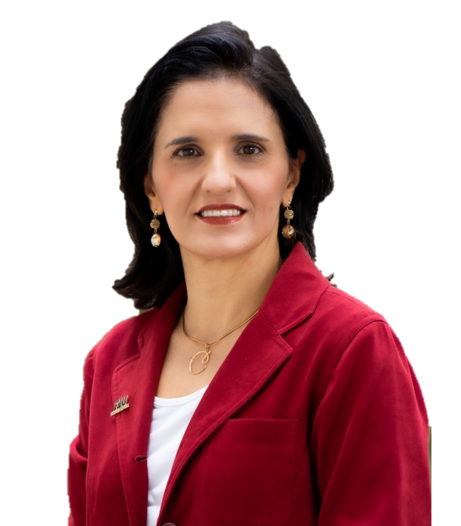
We are delighted that you have chosen the Department of Dietetics and Nutrition to complete your MS degree. Our faculty are dedicated to your education and training.
Your success depends on careful planning and hard work. It also depends on the relationships you develop with the graduate faculty, and the other graduate students in the Department. We hope this learning experience will help you make meaningful contributions to the profession in the future.

We truly wish you much success!!

Cristina Palacios, PhD, MS
Professor and Chair

Welcome from the M.S. Program Director
We are delighted to have you join our Masters program. Our goal is for you to be trained in promoting nutrition using a scientific and applied knowledge base to advance the dietetic profession.
Our MS curriculum prepares you to become a professional recognized for your expertise in foods, nutrition and dietetics. We also offer you the opportunity to apply to our nationally accredited practice program (internship) at the graduate level.



We are excited for you start your graduate journey with us and wish you the very best!

Vijaya Narayanan, Ph.D.
Clinical Associate Professor
M.S. Program Director

The M.S Program in Dietetics and Nutrition

The Vision

The vision of the department is to be recognized for excellence in dietetics and applied nutrition research, which serves as the catalyst for quality education and responsive community service.
- Conduct research to advance the profession of dietetics and nutrition, promote nutrition as a critical part of disease treatment/prevention and integrate food and nutrition services in clinical, home, and community-based social and health networks, and

- Train dietetics and nutrition professionals who are sensitive to the needs of the population.

Mission Statement

The mission of the Department of Dietetics and Nutrition is to prepare practitioners and applied researchers in dietetics, food, and nutrition to build a healthier society.

Our objectives focus on three synergistic areas:

- Education of dietetics and nutrition majors who are competent, intellectually curious professionals and leaders, and non-majors who value the role of nutrition in overall health.

- Evidenced-based research to advance the profession; to position nutrition in health promotion, disease prevention/treatment, food/foodservice; and to integrate food and nutrition services into the mainstream of health, and home and community-based settings.

- Community/professional service to foster healthy lifestyles through better nutrition over the life course of populations.

Learning Objectives

The focus is on clinical science, education, community and food service.
- Develop a strong knowledge base in dietetics and nutrition.
- Acquire skills in research and critical analysis.
- Develop practical skills such as counseling and education and/or focus in an area of specialization
- Prepare for advanced study or professional practice.

I General Information

Program Information

The M.S, Program was founded in 1980 and has graduated well over 1000 students. The Master of Science program in Dietetics & Nutrition expands and strengthens the knowledge and skills required by students at the graduate level to build successful careers in the field of nutrition with a greater emphasis on clinical science, community, and food service. Students learn the elements of evidence-based research and are prepared for enrollment into doctoral programs or to enter the professional practice of nutrition and dietetics. Our graduates receive enhanced training to serve the community through the promotion of healthier lifestyles across various populations.
- Students may use their electives (9 credits) to pick an area of emphasis such as the Sports Nutrition specialization or the Infant and Childhood Nutrition specialization.
- Toward the end of the MS program, students may apply to the Dietetic Internship (DI), which is only open to MS students. The DI is fully accredited by ACEND and prepares competent entry-level Registered Dietitian Nutritionists (RDNs) – through experiential learning and evidence-based practice – to become leaders who are ethically and culturally proficient. The DI is committed to training qualified practitioners who can provide dietetic services that promote eating and lifestyle behaviors that enhance health and promote quality of life.
- Students may opt to complete 5 courses (15 credits) to obtain the Graduate Certificate in Pediatric Nutrition. Upto 9 credits of these courses can be used toward completion of the M.S. electives.

This document, “MS in Dietetics and Nutrition Program Handbook,” serves as a resource for Dietetics and Nutrition MS students in the Stempel College. The Dietetics and Nutrition MS program operates under the FIU University Graduate School (UGS) and thus adheres to all University Graduate School procedures. It is the student’s responsibility to ensure that he/she not only is in compliance with the requirements of the Stempel College, but is also in compliance with the requirements of the University Graduate School. In cases of discrepancies between this handbook and University Graduate School policies, University Graduate School policies will supersede.
- The Policies and Procedures of the University Graduate School are available at http://gradschool.fiu.edu/facultystaff/#gradpolicies and in the Graduate Catalog (http://catalog.fiu.edu). Students should read all the material at these links carefully.
- The specific policies and procedures can be found here: http://gradschool.fiu.edu/facultystaff/#gradpolicies.

The Graduate Catalog is the final authority in case of conflicts. Failure to follow University Graduate School guidelines and deadlines could result in a delay in graduation. Additional information is available electronically through several sources.
- The web site for the Stempel College is https://stempel.fiu.edu from which you can find a host of documents relating to the Dietetics and Nutrition PhD, including the latest version of this guide.

Full Time Program*
The MS Program is a full-time program requiring a significant investment of time and commitment from students. Most students should be able to complete the program in 4-6 semesters.

Part-Time Program*
Students who enroll on a part-time basis may complete the program in 3+ years.

The University Graduate School allows a maximum of six (6) years to complete a Masters program regardless of the choice of enrollment.

II Admissions

Admission Deadlines

Newly admitted students begin classes during the Fall, Spring or Summer semesters of every year depending on the admittance date. Interested applicants are urged to consult the FIU Graduate School and the Stempel College of Public Health and Social Work websites for other deadlines, scholarships and assistantship applications.

Admission Requirements

The M.S. program is designed to meet the needs of professional practitioners, as well as, students with undergraduate degrees in related fields.

The following are admission requirements of the Department of Dietetics and Nutrition and/or the University Graduate School:

- A Bachelors's degree in dietetics and nutrition (B.S.) or in a closely related field (e.g., biochemistry, food science, molecular biology) from an accredited institution. Prior dietetics and nutrition experience is highly desired.
- A minimum of 3.00 GPA on a scale of 4.0 in the last 60 undergraduate upper division credits from an accredited institution.
- Successful completion of pre-requisites listed below.
PREFIX | COURSE TITLE |  |  | PREFIX | COURSE TITLE
CHM 1045  CHM 1045 Lab  CHM 1046  CHM 1046Lab | General Chemistry I  General Chemistry I Lab  General Chemistry II  General Chemistry II Lab |  |  | HUN 4240  OR  BCH 3033  OR  CHM 4304 | Nutrition and Biochemistry  OR  General Biochemistry  OR  Biological Chemistry I
CHM 2210 | Organic Chemistry I |  |  | MCB 2000 | Intro to Microbiology
CHM 2210Lab | Organic Chemistry I Lab |  |  | MCB 2000 Lab | Intro to Microbiology Lab
CHM 2211  CHM 2211Lab | Organic Chemistry II  Organic Chemistry II Lab |  |  | PCB 3702  OR  HSC 3549 | Intermediate Physiology  OR  Clinical Physiology for Health Professionals
 | OR |  |  | HUN 2201 | Principles of Nutrition
Organic Chemistry I and II can be substituted by:
CHM 2200 – Survey of Organic Chemistry.
CHM 2200Lab – Survey of Organic Chemistry Lab

- Students must fill out an admissions application through http://gradschool.fiu.edu .
- Official transcripts from accredited institutions must be sent directly to the Office of Graduate Admissions.
- Official proof of degree
- Verification Statements:
  - Students who graduated from an ACCREDITED DIETETICS AND NUTRITION PROGRAM IN THE USA, must provide an original copy of their Verification Statement once admitted to the program of study.

International Applicants:
International applicants must submit the documents mentioned above.
- Beginning January 15, 2023 applicants submitting international post-secondary credentials must have the credentials evaluated and translated by an NACES member translation service. The applicant will need to provide the service official credentials, but the evaluated and translated credentials will be accepted directly from the service provider with no additional requirement of an original credential. We will no longer accept any post-secondary academic credentials unless they are evaluated and translated by a provider. NACES membership ensures the provider adheres to a set of standards and operates with integrity.
- International applicants whose native language is not English are required to submit a score for the Test of English as a Foreign Language (TOEFL) or for the International English Language Testing System (IELTS). A total score of 80 on the iBT TOEFL or a 6.5 overall on the IELTS is required.
- Students must complete the Declaration of Finances Form located in in https://admissions.fiu.edu/how-to-apply/international-applicant/index.html
Official bank letters must be submitted.
- A Financial Sponsor Letter must be submitted.
- International Students (currently in the USA) must submit their F1-Transfer Forms located in https://admissions.fiu.edu/how-to-apply/international-applicant/index.html

Applicants are responsible to ensure that required documents are received at the Office of Graduate Admissions at FIU by the stated deadlines. Please refer to the Department of Dietetics and Nutrition website for instructions on where to send each document: http://stempel.fiu.edu/. The Admissions Committee reviews only completed applications.

Areas of specialization

As of Fall 2025, students can choose to pursue the M.S. in Dietetics and Nutrition without selecting a specialization or choose from one of the following areas of specialization given below.
- Sports Nutrition Specialization – 9 credits
  - HUN6248 – Sports Nutrition (mandatory)
  - APK5111 – Advanced Exercise Physiology (mandatory)
  - Any one course from the following:
    - PET5216 – Sport and Exercise Psychology or
    - PET5368 – Exercise, Diet and Weight Management or
    - PET5693 – Athletic Performance Assessment and Exercise Prescription or
    - PET5391C – Comprehensive Conditioning of Elite Athletes
- Infant and Childhood Nutrition Specialization – 9 credits
  - Any three courses from the following:
    - DIE6285 – Pregnancy and Lactation or
    - DIE6286 – Pediatric Obesity or
    - DIE6287 – Pediatric Dysfunctional Eating or
    - HUN6415 – Pediatric Nutrition or
    - HUN6416 – Advanced Pediatric Nutrition

Dietetic Internship

Students who wish to become Registered Dietitians (RDs) can meet with the advisor upon acceptance into the M.S. program, to develop an individualized program of study combining graduate and undergraduate coursework to meet the requirements for eligibility to the Dietetic Internship (DI). M.S. students who have completed these didactic requirements are eligible to apply to the FIU dietetic internship. Entry into the dietetic internship requires a separate application during the last semester of graduate coursework.
- Students must complete a 32-week Clinical Practicum under the authorization and supervision of the Director of the DI.
- Only M.S. students who have completed all their didactic requirements in accordance with ACEND (Accredited Council for Education in Nutrition and Dietetics) and graduate program requirements may apply to the DI.
- The deadline for application is the first day of fall semester or the first day of spring semester. Please refer to the University academic calendar for the specific date.
- Students should visit the website at http://stempel.fiu.edu and select Academics – Dietetics and Nutrition – Graduate Programs – Registered Dietitian and/or Dietetic Internship for additional information and application retrieval.
- Students should be aware that application and selection to the DI Program is an internal process – you do not need to apply through the University Graduate Admissions Office or computer matching (DICAS).
- International students admitted to the DI Program must complete their internship through Optional Practical Training (OPT) authorization. To ensure timely processing and avoid delays in starting the program, international students are required to apply for OPT at least 90 days prior to the start of their supervised practice rotations.
  - For guidance and support with the OPT application process, students are encouraged to contact the DI Program Director or visit the FIU Office of International Student & Scholar Services.

Graduate Certificate in Pediatric Nutrition

The Pediatric Certificate Program offers students at the post-baccalaureate level the opportunity to pursue an interdisciplinary concentration in the study of pediatric nutrition. The certificate empowers dietitians/nutritionists and other health care professionals to integrate nutrition into health care and public health settings with pregnant and lactating women, infants and children. The mission of the program is to advance the nutrition and health of children and families by promoting innovation and excellence in pediatric nutrition education, research and civic engagement locally, nationally and globally.
- The certificate program requires the completion of 15 graduate credits.
- The student must have completed an undergraduate dietetics program or equivalent with a strong science background.
- The Graduate Certificate in Pediatric Nutrition is a fully online graduate/professional certificate program that consists of two core courses plus at least three additional specialty courses over an academic year.
Details on the Certificate Program can be obtained here: https://stempel.fiu.edu/academics/dietetics-and-nutrition/certificate-in-pediatric-nutrition/

Graduation Requirements for the M.S Degree

- Satisfy all University requirements for the Master of Science in Dietetics and Nutrition and if applicable the DI requirements as well.
- Complete a minimum of 31 credits of graduate-level coursework in the approved program – this does not include prerequisites.
- Complete Project requirements or Research II – depending on the option selected.
- Earn a minimum GPA of 3.00 in all graduate coursework completed.
- Courses repeated are not eligible for forgiveness policy.
- Students may not receive more than 2 grades of “C⁺”.
- Incomplete or In Progress grades must be resolved prior to graduation. Failing grades in required coursework must also be resolved prior to graduation.
- Meet with Academic Advisor to ensure that graduation requirements are met prior to completing the graduation application in a timely manner.
- Graduate students must be registered for graduate coursework in the semester in which they are seeking to graduate.
- Apply for graduation online at http://onestop.fiu.edu/. (See University Catalog for most current deadlines)

III Post-admission

Initial Advisement

Upon entry into the M.S. program the program director will meet with each student to discuss their interests and initial coursework. The program director will develop an individualized plan of study to meet each student’s goals in a timely manner.

Program of Study

The program of study for the M.S. in Dietetics and Nutrition is comprised of 31 graduate credit hours. The 31 credits are comprised of 22 required credits and 9 elective credits. Depending on the student’s pathway of choice, the number of credits may exceed the minimum of 31. For example:
- If didactic requirements are also being met, students may have to take some additional graduate and undergraduate courses.
- If students opt to complete the graduate certificate in pediatric nutrition, they may take more elective courses resulting in more graduate credits.

Grades

M.S. students are required to maintain a cumulative 3.00 GPA for all their courses. At the masters level, a grade of “A” indicates outstanding performance an “A-” indicates excellent performance. Grade of “B+” indicates very good performance. A grade of “B” is considered a passing grade. Courses in which a student earns a grade of “C” or lower must be taken again (must consult with advisor).

Other

Students admitted to the M.S. program cannot substitute or obtain waivers for required courses. The M.S. Program Director may consider the transfer of graduate level courses toward the completion of a maximum of three elective credit hours with minimum grade of “B” on each course; additional credits require the approval of the Program Director through a petition to the Dean of the University Graduate School (approval of petitions are not guaranteed). Students must explain in writing and provide evidence of how the previous course(s) is/are directly related to the current area of graduate study or provide a syllabus for each additional course in order to evaluate equivalency.

The following is a typical advisement form for the M.S. program.


Master of Science in Dietetics and Nutrition
https://stempel.fiu.edu/
Name: | Panther ID: | Admitted:

Distribution of credits: Nutrition Core (9 credits); Research (10-13 credits); Public Health Core (3 credits); Electives (6-9 credits – see elective section) * = 31 credit hours

I. NUTRITION CORE (9 CREDITS) – Take at least 3 of the 4 courses. One course must be in MICRONUTRIENTS and one course must be in
MACRONUTRIENTS.
PREFIX | cOURSE DESCRIPTION | Semester | GRADE | comments/approval
HUN 5245 | Nutrition and Biochemistry (3)
HUN 6307 | Carbohydrates and Lipids (3)
HUN 6327 | Proteins (3)
HUN 6335 | Functions of Vitamins in Human Nutrition (3)
HUN 6355 | Minerals in Human Nutrition (3)

II. RESEARCH – 10 - 13 CREDITS
PREFIX | COURSE DESCRIPTION | SEMESTER | GRADE | COMMENTS/APPROVAL
STA 6166  PHC 6052  STA 6176 | Statistical Methods in Research (3) OR  Biostatistics I (3) OR  Biostatistics (3)
DIE 6568 | Research I (3)
DIE 6937 | Graduate Seminar in Dietetics & Nutrition (1)
DIE 6576  OR  DIE 6567 | Project in Dietetics and Nutrition (6)  OR  Research II (3) |  |  | Permission from Major Professor is required to  register for Project.

III. PUBLIC HEALTH CORE (3 CREDITS)
PREFIX | COURSE DESCRIPTION | SEMESTER | GRADE | comments/approval
PHC 6500 | Foundation of Public Health Practice (3)

IV. *RECOMMENDED ELECTIVES - 9 CREDITS (If selecting Research II – DIE 6567) / 6 Credits (If selecting Project – DIE 6576)
PREFIX | cOURSE DESCRIPTION | semester | grade | comments/approval
DIE 5247 | Trends in Therapeutic Nutrition (3)
DIE 6128 | Dietetic Administration & Management (3)
DIE 6259 | Management of Nutrition Services (3)
DIE 6285 | Pregnancy and Lactation (3) – (Fall) |  |  | Pediatric Nutrition Certificate Course
DIE 6286 | Pediatric Obesity – (3) – (Spring) |  |  | Pediatric Nutrition Certificate Course
DIE 6287 | Pediatric Dysfunctional Eating – (3) - (Summer) |  |  | Pediatric Nutrition Certificate Course
DIE 6368 | Advanced Techniques in Dietetics Practice (3)
DIE 6368L | Advanced Techniques in Dietetics Practice Lab (1)
DIE 6906 | Readings Dietetics/Nutrition (1-3)
DIE 6907 | Individual Study Diet/Nutr (1-3)
DIE 6915 | Supervised Research (1-3)
DIE 6929 | Specialized Short Course in Dietetics and Nutrition ((1-3)
DIE 6935 | Special Topics in Dietetics (3)
DIE 7566 | Research Concepts Development (3)
HUN 5123 | Ethnic Influences on Nutrition and Food Habits (3)
HUN 5195 | International Nutrition: Problems, Policies & Planning (3)
HUN 5245 | Nutritional Biochemistry (3) |  |  | As long as it is not used as a Nutrition Core
HUN 5611 | Nutrition Education in the Community (3)
HUN 5621 | Food, Nutrition and Communication (3)
HUN 6248 | Sports Nutrition (3)
HUN 6254 | Drug and Nutrient Interaction (3)
HUN 6255 | Nutrition in Wellness Programs (3)
HUN 6257 | Physio/Psychology of Food Intake (3)
HUN 6266 | Nutritional Assessment (3)
HUN 6295 | Contemporary Issues in Food Nutrition (3)
HUN 6307 | Carbohydrates and Lipids (3) |  |  | As long as it is not used as a Nutrition Core
HUN 6327 | Proteins (3) |  |  | As long as it is not used as a Nutrition Core
HUN 6335 | Functions of Vitamins (3) |  |  | As long as it is not used as a Nutrition Core
HUN 6355 | Minerals in Human Nutrition (3) |  |  | As long as it is not used as a Nutrition Core

PREFIX | cOURSE DESCRIPTION | semester | grade | comments/approval
HUN 6415 | Pediatric Nutrition (3) - (Fall) |  |  | Pediatric Nutrition Certificate Course
HUN 6416 | Advanced Pediatric Nutrition (3) - (Spring) |  |  | Pediatric Nutrition Certificate Course
HUN 6417 | Nutrition for the High Risk Infant & Newborn in Intensive Care Unit  (3) – (Summer) |  |  | Pediatric Nutrition Certificate Course
HUN 6435 | Nutrition and Aging (3)
HUN 6522 | Public Health Nutrition (3)
FOS 6236 | Food Toxicology and Food Safety (3)
GEY 5006 | Foundations in Gerontology for Health Professionals (3)
ANT 6469 | Graduate Medical Anthropology (3)

IVa. *REQUIRED ELECTIVES FOR OPTIONAL SPECIALIZATIONS - 9 CREDITS of specific electives as outlined below
- Sports Nutrition Specialization: Students will choose some of the courses from the Dept. of Teaching and Learning (Kinesiology and Exercise Science).
Electives for Sports Nutrition – Required – Minimum of 9 credits:
PREFIX | cOURSE DESCRIPTION | semester | grade | comments/approval
HUN6248 | Sports Nutrition (3) |  |  | Core Course - Required
APK 5111 | Advanced Exercise Physiology (3) |  |  | Core Course - Required
PET 5216 | Sport and Exercise Psychology (3)
PeT 5368 | Exercise, Diet and Weight Management (3)
PET 5693 | Athletic Performance Assessment & Exercise Prescription
PET 5391C | Comprehensive Conditioning of Elite Athletes

- Infant &Childhood Nutrition Specialization: Students will choose some of the courses from the Graduate Certificate in Pediatric Nutrition.
Electives for Infant & Childhood Nutrition – Required – Minimum of 9 credits:
PREFIX | cOURSE DESCRIPTION | semester | grade | comments/approval
HUN 6415 | Pediatric Nutrition (3) |  |  | Basic required course
HUN 6416 | Advanced Pediatric Nutrition (3)
DIE 6285 | Pregnancy and Lactation (3)
DIE 6286 | Pediatric Obesity (3)
DIE 6287 | Pediatric Dysfunctional Eating (3)

Master of Science (M.S.) in Dietetics and Nutrition
Dietetic Internship (DI)

This route is designed for those students who wish to become a registered dietitian (RD). Upon admission into the master’s program, your advisor will work with you to tailor an individualized program of study according to your background, interests and goals. Your advisor will combine graduate and undergraduate courses to meet the requirement for eligibility to apply for the DI. The DI will require a separate application toward the end of graduate coursework.

- Students seeking an RD must complete additional credit courses including a 32-week Clinical Practicum under the authorization and supervision of the Director of the Dietetic Internship.

- In order to apply for the Clinical Practicum students must have completed all of their coursework in accordance with didactic requirements of ACEND (Accredited Council for Education in Nutrition and Dietetics) and graduate program requirements.

- The deadline for application is the first day of fall semester or the first day of spring semester. Please refer to the University academic calendar for specific date.

- Please visit our website at http://stempel.fiu.edu and select Academics – Dietetics and Nutrition – Graduate Programs – Registered Dietitian and/or Dietetic Internship for additional information and application retrieval.

- Please be aware that application and selection to the DI Program is an internal process – you do not need to apply through the University Graduate Admissions Office or computer matching (DICAS).

- International students admitted to the DI Program must complete their internship through Optional Practical Training (OPT) authorization. To ensure timely processing and avoid delays in starting the program, international students are required to apply for OPT at least 90 days prior to the start of their supervised practice rotations. For guidance and support with the OPT application process, students are encouraged to contact the DI Program Director or visit the FIU Office of International Student & Scholar Services.

PREFIX | cOURSE DESCRIPTION | Semester | GRADE | comments/approval
DIE 6946 | Advanced Dietetics Practice I (6)
DIE 6947 | Advanced Dietetics Practice II (6)

Graduation Requirements:

- Satisfy all University requirements for the Master of Science in Dietetics and Nutrition and, if applicable, the Dietetic Internship (DI) requirements.
- Complete a minimum of 31 semester hours of graduate level coursework in approved program. This does not include pre-requisites.
- Complete RD eligibility requirements if applicable.
- Complete Project Requirements or Research II Course– depending upon the option selected.
- Earn a minimum overall GPA of 3.00 in all graduate coursework completed. Note that courses that are repeated are not eligible for the forgiveness policy.
- Students may not receive more than 2 grades of “C+.”
- Resolve incomplete or in progress grades prior to graduation. Resolve failing grades of required coursework prior to graduation.
- Meet with Academic Advisor to assure graduation prior to completing graduation application.
- Graduate Students must be registered for graduate course(s) for the semester in which they are seeking graduation.
- Apply for graduation online at http://onestop.fiu.edu/ (See University Catalog for most current deadlines).

Revised and Updated: October 9, 2025 – VN/JG

IV Master’s Project Option

The M.S. Project is a non-thesis option. It affords the opportunity to conduct applied research, program planning, or program evaluation of a specific dietetics and nutrition problem, topic or existing program in either a community or institutional setting. Students who select the Master’s Project must choose a major professor to direct their project.

The major professor and the student may identify other resource persons to serve in an advisory capacity for the project. Before beginning the project, the student must present a project concept proposal to the major professor. This project will be approved by the Graduate Program Director. The student will write a project report. The student will enroll for six project credits (DIE 6576) in lieu of DIE 6567 Research II.

Research Involving Human Subjects/Animals

All research projects involving human subjects must be approved by the Institutional Review Board (IRB) at FIU and also other involved institutions (see www.osra.fiu.edu/human/index.htm). To receive approval, candidates must submit an Application for Research with Human Subjects to the appropriate IRB committee, following the deadlines and procedures outline in the web site. For human research, see
http://research.fiu.edu/irb/index.html.

Failure to apply for and receive IRB approval can have severe consequences. Instructions for completing the application should be followed. Special attention should be given to the sections dealing with informed consent. These sections require the preparation of a statement concerning the protection of prospective research participants. The information required in an Informed Consent Form includes study dates, purpose, assurances that failure to participate will result in no penalties, right to withdraw and intended uses of the data, etc.

All research projects involving laboratory animals must be approved by the Institutional Animal Care and Use Committee (IACUC) for ethical care and use of animals. The following link outlines the procedures to follow in order to receive approvals. For animal research, see http://research.fiu.edu/iacuc/pages/policies-procedures.html

V AI Policy

Generative AI and Large Language Models like ChatGPT, Microsoft Co-Pilot and Google Gemini are rapidly becoming available. Any use of AI for research and writing purposes MUST be discussed with supervisors, advisors, committee members and other associated individuals. Please be aware that use of AI might lead to data leakage and proliferation, permanence and widespread availability for unverified data. Using AI to write a portion of a project or paper may constitute as plagiarism.

VI Registration Requirements

Minimum Continuous Registration

Unless granted an Official Leave of Absence, all Master’s students and candidates must maintain continuous registration from the starting semester of course work to the completion of all requirements for the degree. This can be done in several ways: (a) registering and paying normal tuition and fees for at least three (3) credit hours per semester during the academic year, or (b) during any semester in which candidates are not otherwise enrolled, registering for one (1) credit hour of Independent Study.

The time limit for completing and awarding of the M.S. degree is six (6) years from admission into the M.S. Program.

Student Grievances

The University Graduate School has a specific procedure regarding student grievances. Details about the grievance procedures can be found here: http://integrity.fiu.edu/grievances.html

VII Financial Aid

Financial Aid

All students requesting research or teaching assistantships must complete a GA/TA application for Dietetics and Nutrition located at our website: http://stempel.fiu.edu

Students are not eligible for any financial assistance if they are working full-time and if they register for less than nine (9) credits per semester.

Most Graduate Teaching and Research Assistantships include a stipend and tuition waivers. Eligible students must meet all admissions requirements and maintain good progress in their course work. In return for this financial support, students are expected to work for approximately 20 hours per week per semester with selected faculty members or teach in the Department as assigned.
Further information on financial support for doctoral students is available from the University Graduate School by visiting http://gradschool.fiu.edu/current-students-graduate-funding.shtml

VIII Important University Websites

Important University Websites

For topics related to Policies and Procedures, Student Academic Conduct, Grading System, Course Descriptions and any other academic and program information please refer to the University Graduate School’s Official Graduate Catalog at: http://catalog.fiu.edu/

Student Conduct and Conflict Resolution: http://conduct.fiu.edu/

For additional University and Student Services, departmental main numbers and a quick glance to all University Services, please refer to the Official University Student Handbook website: http://studentaffairs.fiu.edu/about/student-handbook/index.php

Code of Ethics for the Profession of Dietetics: http://stempel.fiu.edu

For Graduate Dietetics Student Association and other Organizations: http://stempel.fiu.edu

Dietetics Career Opportunities: http://stempel.fiu.edu/academics/dietetics-and-nutrition/resources/

Official Dietetics Website: www.eatright.org

Dietetics Student Resources: http://stempel.fiu.edu

